
A14
Sreenidhi Institute of Science and Technology
(An Autonomous Institution)
Code No: 4AC41
B. TECH. II-Year I-Semester Examinations, December 2015 (Regular)
BASIC ELECTRICAL ENGINEERING (ME, CSE & IT)

Time: 3 Hours Max. Marks: 70

Note: No additional answer sheets will be provided.

Part - A
Max.Marks:20

Answer all QUESTIONS. EACH QUESTION CARRIES 2 MARKS.
- State & Explain the Kirchoff’s Current law with an example.
- Capacitors of 0.2μF, 05 μF, 0.8 μF are connected in parallel. Determine the effective capacitance and the reactance if they are excited by a supply of 50Hz.
- Explain the applications of a DC motor.
- What is the principle of working of a Transformer?
- Explain the term Slip.
- What are the different types of torques present in an Indicating Instrument?
- What are the limitations of Superposition Theorem?
- What do you mean by Regulation, Give the relation for Regulation in a Transformer?
- Give the relations for Line and Phase voltages for a 3 Phase Balanced Delta connected system.
- Define the terms Form factor and peak factor and give their values for a sinusoidal signal.

Part – B
Max.Marks:50
ANSWER ANY FIVE QUESTIONS. EACH QUESTION CARRIES 10 MARKS.
- a) Derive the expression for the resistances of a Star to delta transformation network. (4M)
b) Obtain the equivalent resistance R_{ab} in the circuit shown in figure 1 below (6M)
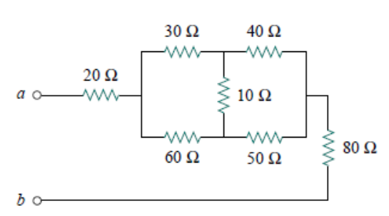
Figure 1
- a) Define the terms RMS Value and Average value and obtain its values for Half Wave Rectified Sine Wave
b) Find i(t) and V(t) for the circuit shown in figure 2 below
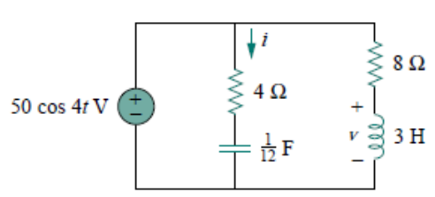
Figure 2
- a) Obtain the expression for the torque of a DC Motor
b) A DC motor takes and armature current of 110A at 480V. The armature circuit resistance is 0.2Ω. The machine has 6 poles and is lap connected with 864 conductors. The flux per pole is 0.05Wb. Calculate the
(i) speed
(ii) torque developed by the machine

- A 5 KVA 400 / 200V, 50Hz 1Φ transformer gave the following test results. O.C.Test: 400V, 2A, 120W; S.C.Test : 20V, 20A, 80W. Calculate the full load efficiency.

- Explain the concept of generation of Rotating Magnetic Field in an Induction Motor.

- With the help of a neat sketch explain the principle of working of a Permanent Magnet Moving Coil instrument

- a)Determine Vo using Superposition Principle for the circuit shown in figure 3below 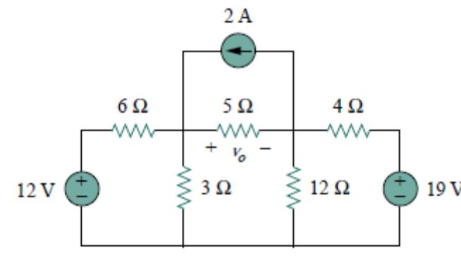
b) Two impedances Z₁=(8 + j6) and Z₂=(3 - j4) are connected in parallel. If the total current of the combination is 25A, find the current taken and power consumed by each impedance.

- a) A 2000KVA, 3300 / 240 V, 50Hz 1Φ transformer has 80 turns in the secondary winding. Assuming an ideal transformer, calculate
(i) Primary and secondary currents on full load.
(ii) Maximum value of the flux and.
(iii) The no of primary turns.
b) Explain the Torque Vs Slip Charactersistics of a 3 Ph Induction Motor.

-- 00 -- 00 --

